Additional Breeder Seed Production Centres
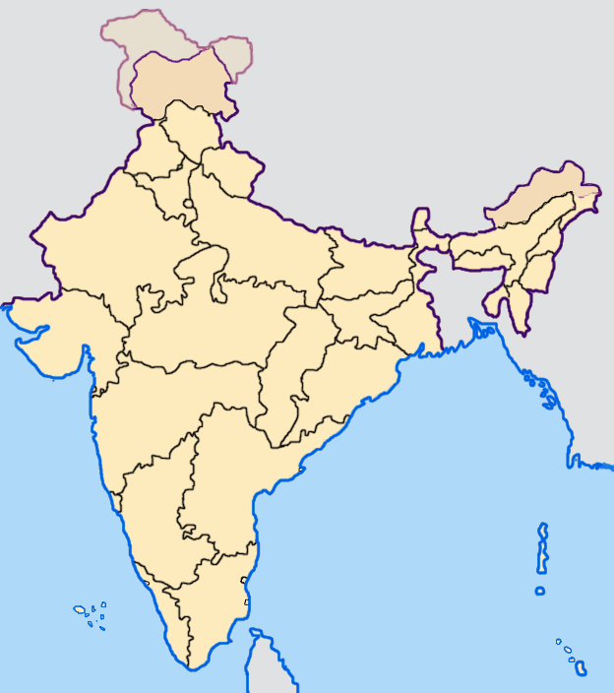
.
.
.
.
.
.
.
.
.
.
.
.
. ICAR-IIPR, Kanpur
Nodal Centre

. ICAR-IIPR Kanpur
BAU, Sabour
ARS Lam
ARS Badnapur
MPKV Rahuri
ICAR-IIPR RS Bhopal
JNKVV Jabalpur
RVSKVV Gwalior
RARI Durgapura
ARS Kota
ARS Berhampur
UAS Dharwad

